**Section 1–2: Properties of Real Numbers**

It is very important to distinguish between a rational number and an irrational number. It will be wise to understand the diagram below.

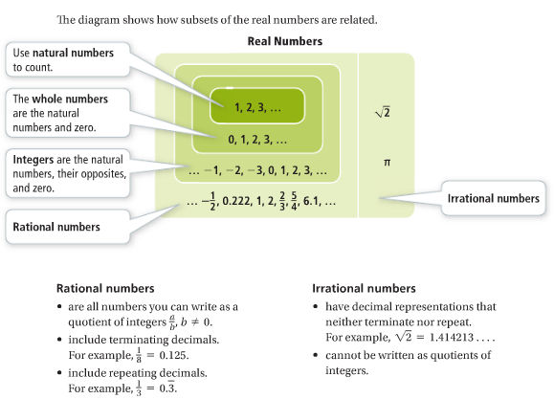

**Signs:**

1. = less than 2. = less than or equal to

3. = greater than 4. $≥$ = greater than or equal to

**Example 1: Ordering Real Numbers**

How do $\sqrt{26}$ and 6.25 compare? Use > or <.

First, don’t panic and start grabbing your calculator just because you see the value of $\sqrt{26}$. This problem can be easily solved if you remembered the square value of natural numbers. If you take a look at the value of $\sqrt{25}$ (which equals to 5) and $\sqrt{36}$ (which equals to 6), then you can ***estimate*** the value of $\sqrt{26}$ to be just a little bit greater than 5. From that, you can draw the conclusion that $\sqrt{26}$ **is less than $6.25$**  or $\sqrt{26}<6.25$.

**Special Value – Zero (0):**

One property of real numbers excludes a single number, zero. Zero is the *additive identity* for the real numbers, and zero is the one real number that has no *multiplicative inverse*.

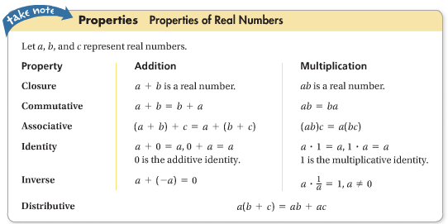

**Key Points:**

1. The **opposite** or **additive inverse** of any number *a* is –*a*.

**Example:** The additive inverse of 8 is –8.

1. The sum of a number and its opposite is 0, the additive identity.

**Example: $-8+8=0$**

1. The **reciprocal** or **multiplicative inverse** of any nonzero number *a* is $\frac{1}{a}$.

**Example:** The multiplicative inverse of 8 is $\frac{1}{8}$ or –8 is $-\frac{1}{8}$.

1. The product of a number and its reciprocal is 1, the multiplicative identity.

**Example: $8\left(\frac{1}{8}\right)=1$**  or $-8\left(-\frac{1}{8}\right)=1$